thorlabs产品平替：
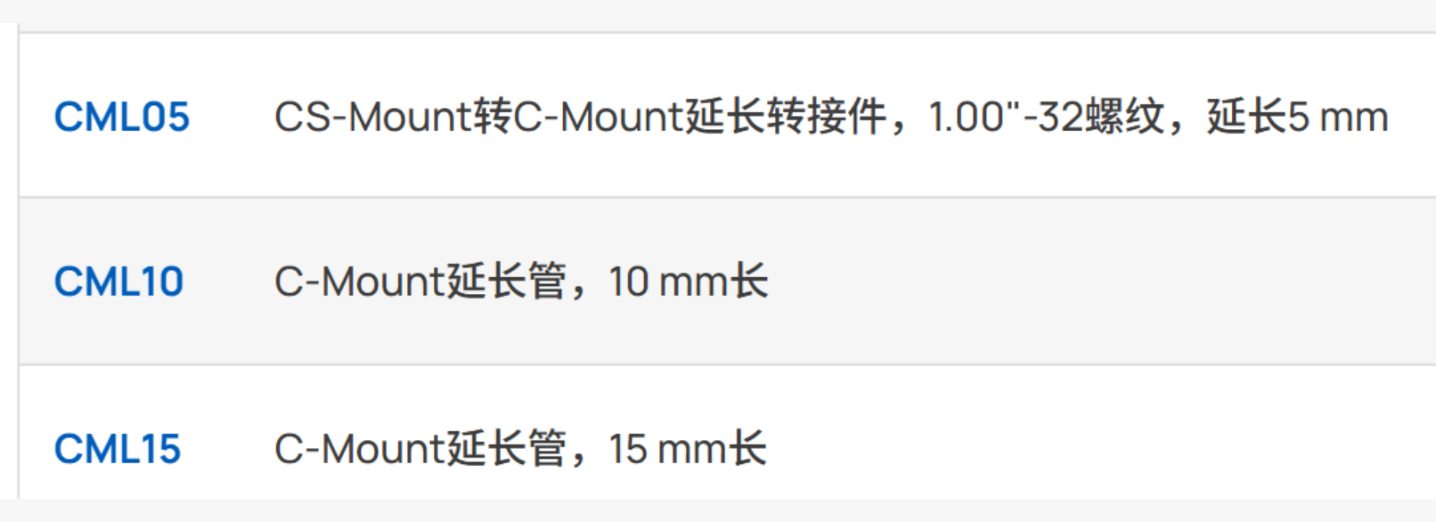
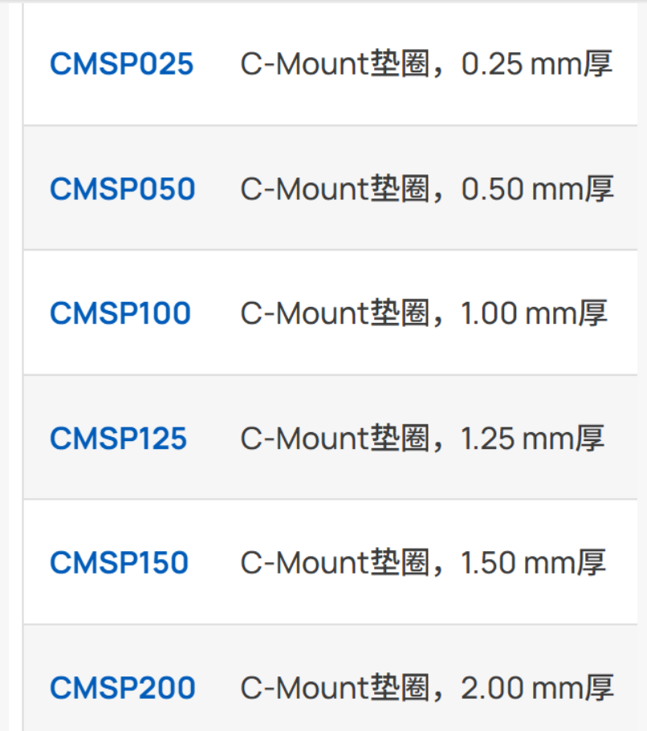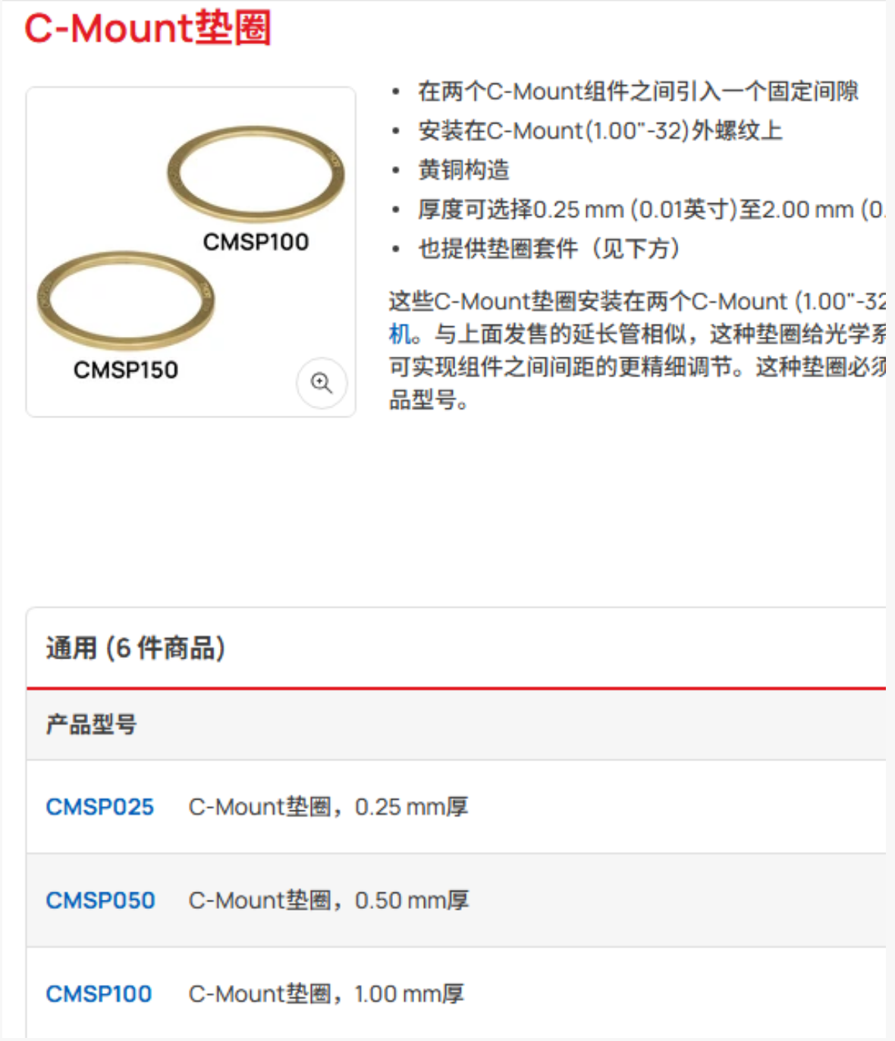
工术铜质垫圈链接：
https://item.taobao.com/item.htm?id=740195478215&pisk=hkArBr9legExVx1JAS4fWfMbz_LRv3VQO6sSnnSD4W9WPebhTnxIygTn2HRFm3PBFUT38wxfTci1KJ-dc1bF-aqCKtY0qVwbofG6yEz5rVTDd9TMcZbhtajlxs0V-wZht9f3nq7hRu23ZHYmuwIc-8XutsqcRwe3xHVloEbCz8V3ZWXciNscx6XhEq8cDw5hxHfnuEbuMWJjO5F8Emr4ZN3CzTSUOiWdQ2_E8GT50cj9iaROjtd42zOkceAWwteiQ6LXQHJHx0P5kdtWwt9zmDSMF3KeSlFUOhaIUmApY3pJ7oD6MLOVII-TyjAiOI-J5eVtQVAHHF5MloGqzmRJuLAUQjct1eYyPIUioIH6iIdkmR3EW4svbKBAuZRyxMXf7KkcWJedn1QVf4_7pJBlkZSsPawLptbOuGg5P&spm=pc_detail.30350276.202205.15.2a4671dexJQkeg&sku_properties=1627207%3A35489267291
工术Cmount延长管链接：
https://item.taobao.com/item.htm?id=741002145581&mi_id=0000QoG7Le8cYGJef6mNHyMlxOusrC1zIGBlBFkIx0n5b18&spm=a1z10.3-c-s.w4002-23863065301.11.1af82c3cNTAwgl&skuId=5962749281589

产品代买：延长管和1个可调扳手或者筒状的扳手
1、卖C-mount 延长管
https://item.taobao.com/item.htm?abbucket=7&id=692470718078&mi_id=0000HpIaqymuXHOUZqDcLWVx_hzisaxTWc7JRQpM3px-eos&ns=1&priceTId=2147845a17859007318304115e0f30&spm=a21n57.1.hoverItem.10&utparam=%7B%22aplus_abtest%22%3A%2258bcf2be4eaea20f077e779f84220e01%22%7D&xxc=taobaoSearch&skuId=5090275487934
- 延长管
https://item.taobao.com/item.htm?abbucket=7&id=741002145581&mi_id=0000KZS8D8zMbGtyL8CUSwRxPNKm1AwObPvjirHPXSlqdlA&ns=1&priceTId=2147845a17859009995905392e0f30&skuId=5962749281590&spm=a21n57.1.hoverItem.11&utparam=%7B%22aplus_abtest%22%3A%22a9e260c5787cfc97b2bb7766e455a4bc%22%7D&xxc=taobaoSearch
3、可调扳手或者筒状扳手均可
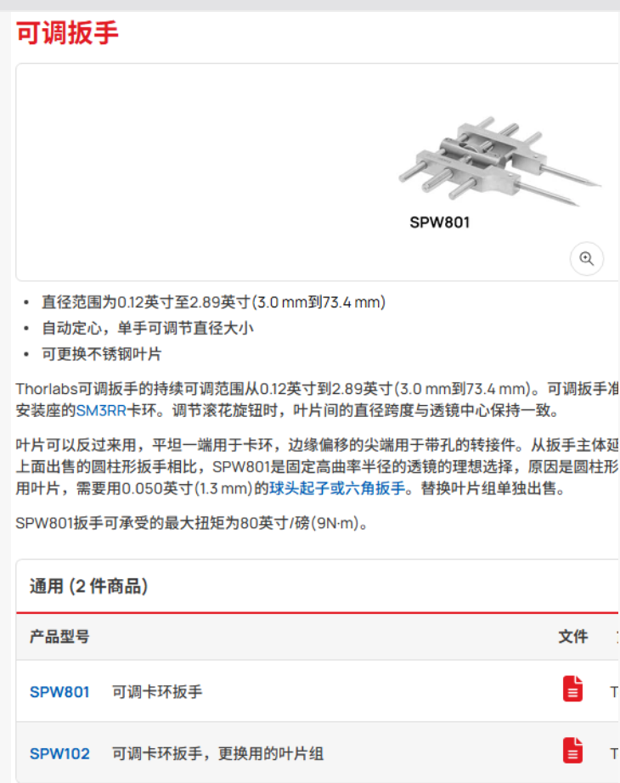
扳手这个找宁经理她有个匠才同款的那个价格更低的厂家

